OXTON HOCKEY CLUB

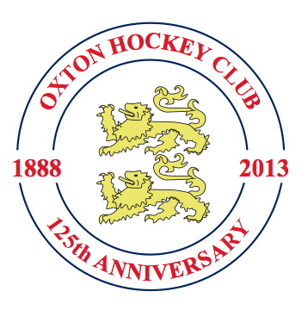

HISTORY

1888-2013

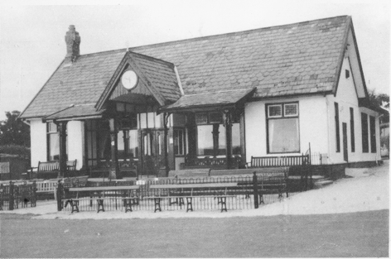

PART 1

CENTENARY HISTORY
1888-1988

Introduction

‘A ball game played with sticks and clubs’

That is how the dictionary describes hockey and it adds that it was a development of shinty, which suggests an Irish connection. One encyclopedia went on to suggest that a game resembling hockey was played by the Aztecs.

At first it seems to have been a murderous free-for-all affair and it was not until 1888 that a simple form of rules was introduced which regulated the size of the stick or club and of the goal and it forbade such activities as playing the ball with the back of the stick, raising it above the shoulders and charging, tripping, kicking and shinning. It was not until later that fly hitting and stopping the ball with feet, legs and hands was outlawed.

Early History

The Hockey Association was formed in 1886, and Oxton was affiliated to it in 1892.

Just how the Oxton Club came to be founded, and by whom and for whom, and for that matter, exactly when, will probably never be established. By 1888, some of the merchants of Liverpool had built their large homes around Birkenhead Park and one must presume that they founded the Club to provide and outlet for the energy of their sons who had been educated at the public schools, where physical fitness, under the influence of Dr. Thomas Arnold, was a fetish. Muscular Christianity and cold water were the order of the day. But all the early Club records and minutes books have been lost. When the late Duke Ellington was asked why so many of his scores had disappeared he succinctly replied, “People wrap their lunch in them”. Whether the Oxton records suffered that or perhaps an even more humiliating fate, we shall never know for certain. What is certain, however, is that a number of clubs in Cheshire, for example, Bowdon (1887), Timperley (1886), Sale and Alderley Edge (both 1888) were founded at about the same time and that Oxton played against them, the players presumably travelling by train. The Cheshire Hockey Association was also founded in 1888, in the same year as Oxton.

W. Whinnerah, who joined the Club in 1894 and who was for many years the G.O.M. of the Club, is on record as having said that in the early years Oxton played at Birkenhead Park.

However, we must now go backwards in time to 1875, the year of the foundation of the Oxton Cricket Club. The first action of the Committee of that Club was to lease (and later to buy) a piece of land at Townfield Lane, formerly Shoe Lane, from the Earl of Shrewsbury’s estate, a fine field in open country on the west side of the Oxton ridge. Work immediately started on the preparation of the ground, followed in 1877 by the construction of the pavilion, which was extended in 1883. The frontage has survived to this day.

It seems likely that the Oxton Cricket Club approached the Oxton Hockey Club in the very early days to suggest that they share the use of the new playing field, but it is believed that the Hockey Club declined the offer, presumably because of its inaccessibility, and that they continued to play in Birkenhead Park at least until the turn of the century. By that time large houses were built on the Oxton ridge and with the arrival of the electric tramcars on the Shrewsbury Road route, the Townfield Lane site had become much easier of access. There may have been difficulties with Birkenhead Park as well, but for whatever reason we see the Hockey Club taking up the tenancy of two pitches at Townfield Lane, with the use of the pavilion as well during the winter months - a most satisfactory arrangement which continued till 1967. This probably happened about 1900, certainly before 1906.

County matches were played at Oxton’s ground (presumably in Birkenhead Park) in 1895 against Lancashire in the same year that B. S. Smith played in the first ever International, England vs. Ireland and in 1900 against Middlesex (probably by then at Oxton). In 1905 the North vs. Midland match was played at Oxton.

A true story must intervene at this point. A player called Hickie, who was a member of the second XI, was one Saturday afternoon asked to take a place in the first XI, the Secretary making it clear that this was an honour and a privilege. Hickie replied modestly that he could not play because of a previous engagement. It turned out afterwards that he had been playing for Ireland that afternoon! Indeed, the period between 1903 and 1910 must have been one when the Club was at its strongest, with several Internationals and many County Players as will be seen from the list included in this short history.

C. W. Marshall played six times for England in 1907/8 and sadly died in a climbing accident in 1928 when he was Club President.

Nobody knows for certain what happened to the Club during the 1914-18 War, when so many members must have lost their lives, nor do we know who it was who brought the Club together after the armistice. The outstanding player in the early 20’s was Oxton’s captain, R. M. Stewart, who played for Cheshire thirteen times and captained an undefeated Cheshire side between 1922 and 1924. It seems that there was a flirtation with the Cricket Club, resulting in a first marriage in 1919, followed by a divorce in 1925. Relations with the Cricket Club were always cordial but each must have concluded at that time that it preferred to maintain its independence and separate identity. As always, the records only show that there was concern about spoiling the outfield for cricket.

The Club gathered momentum in the next decade and by 1930 four teams were playing regularly on a Saturday, two at home and two away.

The arrival of the internal combustion engine had increased the Club’s mobility and range. A fixture was arranged at Uppingham in 1929, the headmaster allegedly stipulating that the match could only be played if Oxton fielded at least seven Old Uppinghamians in their side - a condition that was fortunately dropped in later years. With Gordon Ravenscroft as Captain, the Oxton side on that March afternoon was soundly thrashed by the schoolboys. This is the origin of the Spring weekend tour which has taken place almost every year, except during the Second World War. It has given enjoyment to many, especially to the married members who were able temporarily to forget their family responsibilities and domestic duties and spend a weekend in the masculine gender.

Until the thirties, most of the new recruits came from the Universities and from public schools in the South of England, where hockey was already well established, but interest in hockey was gathering pace in other places and many schools in the North of England began to teach it as an alternative to football in the Easter term. Most importantly for Oxton, Birkenhead and Calday Grange Grammar School continued to play hockey under the guidance of Bill Frankland and Guy Jarrett, an Oxford Blue and Cheshire County Player, at Birkenhead, and Frank Lamb, followed by Peter Cross, at Calday. All were members of Oxton, then the only senior hockey club in Wirral. Birkenhead’s commitment to hockey was perhaps lukewarm because it competed with athletics and it was thought that the headmaster, W. F. Bushell, believed hockey to be an effeminate sport, inferior to rugby for the building of character, but at Calday, which was to expand rapidly after the war, the attachment to the game was unequivocal and Calday was soon to provide an extraordinarily useful and fertile nursery which contributed many outstanding players and a few captains as well.

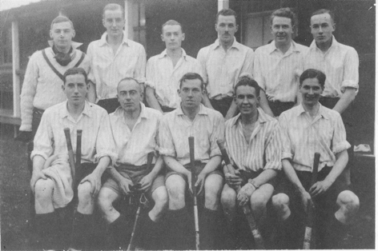
2nd XI About 1930

Another result of the arrival of the motor car was a great expansion of the Club’s catchment area, and Oxton was now attracting members who lived at West Kirby, Hoylake, Bebington and Heswall. Most members could borrow the family motor car or solicit a lift from friends for a far away game on a Saturday afternoon. It was before the days of the breathalyser and frequent stops were usually made on the return journey for refreshment at 6d. per pint.

Most of the games on the fixture list were against clubs in East Cheshire and West Lancashire - Bowdon, Brooklands, Southport, Northern, Sale, Hightown, Sefton and West Derby, to mention a few. For a modest subscription of a guinea or two a year, members could play against all the finest clubs in the Northwest of England.

Opponents poked fun at Oxton for their playing colours, narrow blue stripes on a white shirt, nicknamed pyjama jackets.

Neil McLaren, who occasionally played for Cheshire, was Captain of the first XI during the early 30’s when the Club was holding its own but produced few players of great distinction and he was followed by Donald Crawford. What the Club lacked in skill it made up in enthusiasm and determination. Perhaps because everybody knew that war was imminent, it seems that no particular event were planned to celebrate the Club’s Golden Jubilee in 1938.

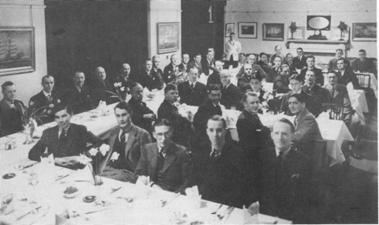
1938 Hot-Pot at Liverpool Constitution Club in India Buildings

The Second World War again interrupts the story when, for the second time in its history, the Club went into suspense. This time it was held together by Donald Crawford (Captain), Philip McGill (Hon. Secretary) and Jim Bibby (Hon. Treasurer). A single team played a few games in the Winter of 1945/46 and there was a short tour in a quartet of elderly motor cars in the Spring of 1946 with games against Bromsgrove and Market Drayton, during which plans were laid for a resumption of activities with two XI’s during the next season.

Immediate Post 1945 History

One of Oxton’s crowning moments of glory came on 19th December 1947, when the second XI beat a local club 19 - 0. It was a riot and the score was inadvertently published that evening in the Liverpool Echo among the rugby results.

1947 also saw the retirement of Philip McGill, Hon. Secretary for twenty years. Philip had been the sheet anchor of the Club through difficult times. With his bulky figure and shock of white hair, Philip kept goal for the first XI with astonishing agility right up to his retirement. He was father confessor to many of the younger members. He died quite shortly afterwards, tragically and suddenly, whilst playing cricket at Neston. Geoffrey Beavan succeeded him as Hon. Secretary, an office which he held for nine years. Geoffrey was later to be elected a member of the Cheshire County Executive Committee and subsequently a Vice President of Cheshire.

The traditional pyjama jackets, which had characterised the Club for sixty years and which provided so much innocent amusement for its opponents, were abandoned after the War, owing to the prohibitively high cost of manufacture. Their passing was mourned by the fundamentalists, but plain bright red shirts were to be worn by Oxton from now on. Originally these were in heavy flannel, becoming extremely heavy in wet weather. Over the years the material has become considerably lighter and sponsors names have recently appeared and numbering has become a requirement of the ‘Leagues’.

As the Club settled down to serious business after the War there were a number of changes in the captaincy. Talbot Davenport succeeded Donald Crawford and he in turn was followed in rapid succession by Noel Thompson, an Irish international player, Archie Crawford, Dennis Scott, Herbert Bibby, Clifford Cook and Michael Walker. The situation was stabilised under the leadership of Hesketh Hughes an experienced player, soon to represent Cheshire, and the first of several Old Caldeians to captain the Club. Other clubs were in the ascendancy at the time and Oxton was going through a lean patch, but no club can be expected to succeed under eight different captains in eight years any more than a company can prosper under eight managing directors in eight years.

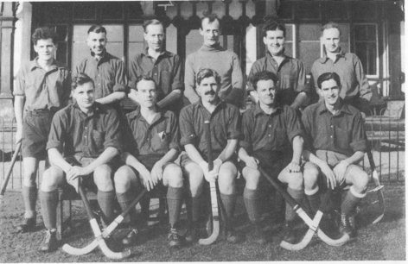
1st XI - 1952

The Schools Tour

The March Schools tour continued to be a great event of the year. During the early 50’s there were usually three games, on the Friday and Saturday against Bromsgrove and Uppingham Schools respectively and the third on the Sunday against Evesham or another Midlands club side and two XI’s took part. An omnibus and driver were hired from Hardings, partly for reasons of economy and partly to promote good fellowship and to accommodate a card table as well. Players generally behaved in a gentlemanly fashion at the hotels at which they were boarded, but there were sometimes high-spirited adventures which caused little local difficulties. At dinner one evening, a mischievous junior member placed some cutlery in the captain’s trousers pocket, and as the captain was leaving the restaurant, the Head Waiter held him with the charge, “Excuse me, sir, but I believe that you have some of our property on your person, sir”. It took all Clifford Cook’s powers of advocacy to prevent the manager from calling the Nottingham Police. The cost of the tour then, including transport, accommodation at a first-class hotel and all meals worked out at £7.10s. per person, but it was still more than some members could afford.

The fixtures on the Schools tour have changed over the years and now involve playing Oundle School on the Friday, two sides from the Cheltenham area on the Saturday and Cheltenham Hockey Club on the Sunday. Since the 1950’s when the schools involved were Bromsgrove, Uppingham and Worksop, Worksop (with its monastic surrounds) dropped out in 1973, Uppingham (with its notoriously heavy clay pitches and custom of dividing up the Tourists between its 12 ‘Houses’ for a restricting dumpling lunch) in 1978 and Bromsgrove in 1981, being replaced in the meantime by different permutations of Midlands Clubs, in particular, GEC Rugby, for approximately 8 years, Hampton in Arden, Stafford and Cheltenham. The team or until recently two teams, stayed at Leicester for many years before Mike Flynn introduced the Cheltenham fixtures in 1984. Cheltenham has now become the preferred overnight stopping place.

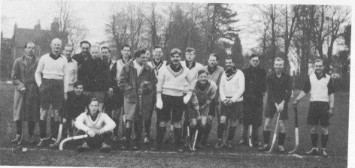
Uppingham Tour about 1955

The Clubhouse

The changing rooms in the pavilion had not been improved since the reign of Queen Victoria and the plumbing was as primitive as in a third rate French provincial hotel. In 1959 the Cricket Club, realising that the conditions therein compared unfavourably with other clubs in the same class, launched an appeal for cash, to which the Hockey Club subscribed, to extend and modernise the arrangements in the nether regions of the pavilion. Electricity had at last arrived at Townfield Lane and electric bulbs now replaced the gas mantles. Never luxurious, the locker rooms now at least rivalled what was being offered elsewhere.

Improvements to the heating and furnishings have been made at intervals, but the exterior appearance is almost exactly the same as when hockey was first played at Oxton in approximately 1900.

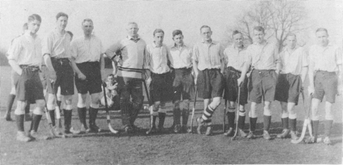
Uppingham Tour about 1932

The 1950’s

The mid-50’s saw a recovery in Oxton’s fortunes. There were now more victories than defeats and draws. Some outstanding players had joined the Club and Oxton was strongly represented in the Cheshire XI, sometimes contributing half the side. Among those who played regularly for Cheshire at this time were Peter Cross, Michael Walker, John Boden, Hesketh Hughes, Ken Pyke and Donald Hughes, the last also a Welsh International player. These were Oxton’s star performers in the 50’s. During the season 1957/8, with Peter Cross as captain, only two games were lost. Five teams were fielded for the first time in 1952, six teams were being fielded every Saturday by 1958 and they were all giving a good account of themselves. Nothing succeeds like success and a more professional and earnest approach to the game had paid dividends. Competition for a place in the First XI was never so keen and Oxton had become recognised as one of the most formidable clubs in the Northwest of England. There was a waiting list to join.

The results in the 1950’s and pre-‘league’ 1960’s were always markedly affected by the fact that County Matches were then played on Saturdays. With eleven members first playing for Cheshire in the 1950’s and a further twelve first playing for Cheshire in the 1960’s, there were at least five fixtures when the best four or five players would be absent on County duty and further occasions when International duty and training weekends would make them unavailable for the Club. All this made for much prestige, but also for considerable selection difficulties.

The strength of the Club can then be judged also by the wealth of skill and experience in the 2nd and 3rd XI Captains in that era: Keith Newell, John Allen, Peter Jones, Tom Wilson, John Bordass and Geoff Porter, to name but a few.
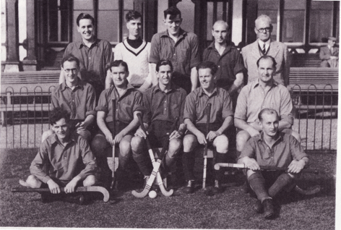
1st XI - 1955

The 75th Anniversary

The Club was now approaching its 75th Anniversary and plans were made for suitable celebrations. The Oxton Club had always been a social as well as a Hockey Club, with an annual Dinner Dance for the wives and sweethearts and a more bawdy Hot Pot supper, usually held in a Liverpool club or restaurant. Something special had to be done. In 1963/64, Roger Ball was President and Ken Pyke was Captain. On 29th February 1964, a special match was arranged at Oxton against the Reading Club, with whom Oxton had had several previous encounters on the London Tour and the honours were even. This was followed by a celebration dinner at the Grosvenor Hotel, Chester and the health of the club was proposed by J. Allured, President of the Northern Counties Hockey Association, to which Roger Ball responded. The toast to the guests was proposed by Peter Cross to which Dennis Korff of Deeside Ramblers replied. There were present about 150 members and guests, including the Reading team. Afterwards, some of the diners retired to a late night session at Chester’s then fashionable Ten Pin Bowling Alley, where the locals were somewhat surprised by so many players in evening dress.

Oxton Hockey Club
1961-62
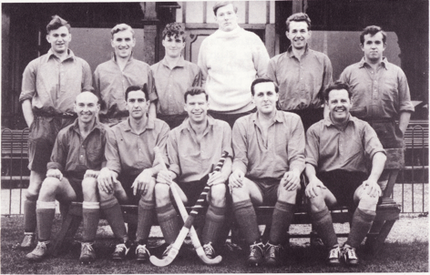
T.J. Guffick P.N. Crutchley R.D. Lapthorne K.R. Lyon K.D. Lloyd D.E. Costain
G.A. Sheppard H.R. Hughes D.C. Hughes K.N. Pyke P.M. Cross

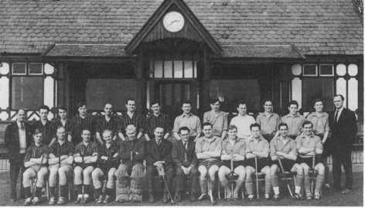
Oxton Hockey Club, 75th Anniversary 1964
Celebration Game - Oxton v Reading

The 1967 Amalgamation Debate

The matter of the rent of the ground from the Cricket Club had always, quite unreasonably, been a burning issue, or at least a hot potato, and shortly after the 75th Anniversary celebration, there arose a demand for an improvement in the playing surfaces and a ‘final solution’. Quite a sizeable and vocal fraction favoured leaving Oxton altogether and merging with the newly-formed hockey club at Neston, whilst the silent majority leaned towards an amalgamation with the Club’s landlord, the Oxton Cricket Club. In the season 1965/66, Clive Collins was President and the veteran Hesketh Hughes was doing his second stint as Captain of the First XI. At a lively General Meeting in 1965, Clive had sought, and obtained by a majority vote, members’ agreement to seek a full merger with the Cricket Club. Rodney Lyon and Peter Jones were to assist him in the discussions that were to follow. in March 1966, Clive was able to tell members that progress had been made on the terms of a union which would give hockey players proper representation on the various committees of a merged club with a very much larger membership and which would also provide them, now that provision had to be made for six XI’s, with a much needed third playing pitch. There must have been arguments during the somewhat delicate and protracted negotiation, but the marriage was eventually agreed by both parties. However, it was not until the General Meeting in 1967, with Gruff Evans, later Lord Evans of Claughton, as the new President (the last President, as it turned out, of Oxton Hockey Club) that consummation actually took place. From henceforth the Club would be know as ‘Oxton Cricket Club, Hockey Section’. The marriage, after such a controversial engagement, has been a stable, happy and fruitful one, but it did not prevent a number of members from breaking away and joining Neston. The ‘Cricket’ Club has subsequently recognised a number of the Hockey Section members by honouring them with election as President of Oxton ‘Cricket’ Club, namely Ashby Collins, David Renison and, in the Hockey Centenary year, Lord Evans of Claughton, better known to his hockey colleagues as Gruff Evans.

In 1967 the ‘new’ pitch was levelled out of scrubland on the farthest point of the grounds from the pavilion. Intended as the essential third pitch to accommodate six sides, it was also intended to provide a pitch of full width and high quality surface so that County Matches would again be attracted to Oxton. Generously funded in large part by Ashby and Clive Collins, it proved to have been built on clay, which has, so far, proved impossible to drain adequately in the mid-winter months. A great disappointment to its donors and to the Club. It has, however, provided a surface for the playing of summer hockey without disturbing the Cricketing facilities.

League Hockey

The advent of ‘League’ Hockey in 1969 was not greeted with enthusiasm by Oxton at the time and, indeed, they were the only Club to vote against it at the Cheshire Hockey Association Meeting at which it was inaugurated.

Initially, the League was instituted on a percentage basis, with Club’s not altering their fixtures but merely counting in the table those fixtures which were played against other clubs playing sufficient fixtures against league opponents to qualify.

Oxton were reasonably successful at the initial stages, since they still had the remnant of their successful sides of the early 1960’s.

The Northwest League as it was then known was made more formal in 1971, with teams being forced to alter their fixture list to accommodate fixtures against every side in their league and with promotion and relegation introduced for the top and bottom two clubs in each division. Oxton were again reasonably successful in the initial years, sometimes threatening but never achieving a position in the top two of the First Division.

The end of the 1976/77 Season marked the end of Oxton’s dominance of hockey on the Wirral. Five International players left that year for varying reasons, although only one went to the new ‘rivals’ at Neston. The Club had absorbed the loss of approximately half its top two teams in 1967 when the debate between amalgamating with the Cricket Club or moving en bloc to Neston had taken place. It could not so easily absorb this second exodus.

By the end of the 1970’s, Oxton was starting to struggle towards the bottom of the First Division and Captains, including Rob Collins, Howard Roberts and David Billington, frequently faced the prospect of relegation, mainly due to the absence of a consistent goal scoring record and with no conspicuous short corner striker to assist.

In 1979/80, the Club First and Second Teams were relegated to the Second Division for the first time, but the First Team immediately won promotion back to the First Division in the following season. The Second Team has never yet been promoted back to the First Division of its League.

The Club was again relegated to the Second Division in the 1982/83 Season and relegated to the Third Division in the 1986/87 Season.

With the formation of two National Leagues of 16 clubs each after the 1987/88 Season and the formation at the same time of the Northern Premier League, Oxton was promoted from the Third Division of the Northwest League to the Second Division at the end of that season.

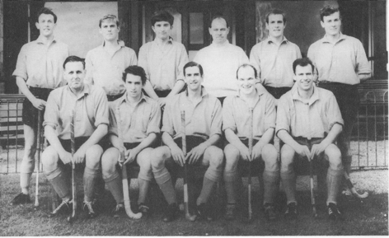
1st XI - 1967

Accordingly, for the 1988/89 Season, of Oxton’s normal past opposition Clubs, Warrington is in the National League Division I, Neston in the National League Division II, Bowdon, Brooklands, Timperley, Alderley Edge, Sefton and Hightown in the Northern Premier League. The Northwest Division I comprises Blackburn, Cheetham Hill, Chester, Disley, Knutsford, Macclesfield, Manchester Indians, Northern, Northop Hall, Prescot, Preston, Southport, St. Annes, Wigan and Wilmslow. Northwest League Division II comprises Oxton, Deeside Ramblers, Bebington, Bolton, Bramhall, Chorlton, Congleton, Crewe Vagrants, Daten, Liverpool University, Manchester University, Springfields, West Derby, Weston, Winnington Park and Wrexham.

Festival Hockey and London Tour

Festival hockey played an important part in the 1950’s and 1960’s and the Rakes, born at Easter Festivals at Weston-super-Mare and Blackpool, developed under Oxton guidance into a formidable touring side with strong links with Liverpool University, Hightown, Sefton and Northern.

For many years, the Rakes took part in the Easter Festivals at Weston-super-Mare, testing their stamina with four games on Good Friday and Easter Saturday and relaxing on the golf course before the final game and long journey home on Easter Monday. Oxton regulars were Hesketh Hughes, Donald Hughes, Peter Constable, Peter Crutchley, Mike Macadam, Mike Sheppard, Geoff Arnold, Malcolm Robson, Paul Acratopulo, Barry Bramley, Tim Guffick and David Renison, with Noel Cooke, John Cooke and Arthur Fox (all Hightown), Barry Lello, Billy Morton and Albert Connolly (all Sefton), Warwick Hughes (West Derby) and Geoff Poole (Winnington Park) being other distinguished players who helped to establish the side’s reputation. Eventually, the Rakes, bolstered by the younger generation of International players, Bryan Owen, Stewart Edwards and John Forster, moved to Folkestone’s International Festival where top Dutch, German and French sides tested their strength against Ghosts and Tramps, Buccaneers and Ladykillers.

Oxton established some fame as entertainers too, the Reverend Sheppard conducting the Easter Sunday concert and Fingers Arnold (later transferred to Sydney Opera House) assuming the resident-pianist role.

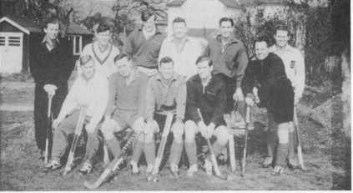
London Tour 1963 ‘A’ Team

The Berkshire Boars (Reading H. C.) became firm allies on and off the field and their journey north for Oxton’s 75th Anniversary was a great success. They stayed at the ‘Bollington Monastery’ where the bar closed early but enjoyed themselves and we repaid them for some marvellous hospitality at their old headquarters at Sonning.

Oxton’s annual visits to London between 1961 and 1966 for the Hurlingham Internationals involved games at Surbiton on Saturday morning and a full day’s tournament at Reading the following day.

It could never be said that these tours were over-organised and Oxton’s Friday evening meetings at The George the 4th in Knightsbridge were always newsworthy. On one occasion fifteen members shared the floor of a nearby flat (Roger Ball and Nick Parry plumped for the reclining seats of the Ball Triumph and hot coffee was served too!). When the owner of the flat appeared in the small hours, an Oxton sleeper told him to watch where he put his feet.

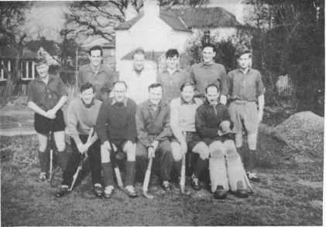
London Tour 1963 ‘B’ Team

Changes Affecting Past Customs

There have been a number of items over the years which have dramatically changed the way in which members have enjoyed their Saturday afternoon hockey. Mention has been made of some of them before. First, travel, where the initial travel by train was replaced by members cars, apart from petrol rationing times: the disappearance of Saturday morning working in approximately 1960 and the subsequent introduction of the ‘breathalyser’ rules has led to the Clubhouse being a much more important focus for meeting before the game and for meeting up again afterwards.

The advent of the motorway system also has changed the pattern of routes to many Clubs and such famous watering holes as ‘The Smoker’ at Lower Peover, the Fiddlers Ferry near the old Warrington Ground and nights out in Chester and Liverpool on the way home, orchestrated by Jack Hardcastle, Ken McBride and others have now largely disappeared. They will be fondly remembered, however, by those who enjoyed them at the time.

The advent of League Hockey, following the 1968 Olympics, has also brought a number of changes to the hockey scene, some of them rather resented by players who enjoyed the previous ways.

In particular, dramatic changing of fixture lists has followed, particularly where the First Team has moved from one league to another; there is much greater emphasis on fitness and therefore midweek training; there is greater importance attached to crucial umpiring decisions and there is now greater mobility of players between the successful clubs and those proving not so successful. All these matters have made their impact.

Pitches

The surface on which hockey has been played has also changed considerably over the last twenty years. First, the introduction of ‘all weather’ shale pitches of different colours, which were playable, on the whole, in all conditions except those of snow and just after frost; secondly, the experimentation with various other artificial surfaces like rubber and lastly, the recent insistence for all international matches to be played on ‘plastic grass’ known as ‘astroturf’. These astroturf pitches now being the most sought after surface. Oxton has used all weather surfaces at the Bebington Oval and more recently at the Woodchurch Leisure Centre, both of these pitches being of the shale type.

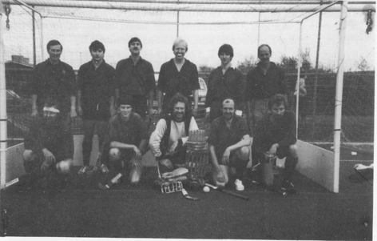
On Astroturf for the First Time - 1985 the 2nd XI at Wigan

The Bebington Oval is likely to have an astroturf pitch installed within the next two seasons and it is hoped that Oxton will shortly have use of another astroturf pitch as part of the possible Tranmere Rovers training facilities. The introduction of astroturf surfaces has certainly changed the speed at which younger players learn, the speed at which the game is played, the level of dribbling skill and the importance of overhead passing. It remains to be seen whether younger players will last so long in their hockey playing careers with the increasing damage done by artificial pitches to knees and all the leg joints. It is also possible that the social basis upon which Club hockey is played in future will be dramatically changed if successive matches are to be played on the one pitch throughout the day, rather than matches taking place simultaneously. Oxton has never had sufficiently good pitches of its own. The advent of astroturf may therefore prove a significant improvement.

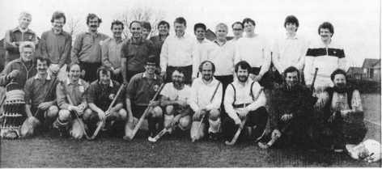
Oxton Veterans at Aylesbury 1987

Veterans Hockey

In the last ten years the advent of organised veterans hockey has made an increasing impact. Until 1988, in Cheshire the Veterans rules required players to be over the age of 40, whereas younger ages had been permitted in different counties. Oxton started to field a competitive Veterans team in the Cheshire Veterans competition in 1987 and has built up enjoyable contacts with Aylesbury (thanks to ex-Second Team Captain Andy Bowes) and Cheltenham (thanks to Mike Flynn, the present Secretary’s up-bringing there) over the last five years, encouraging their welcome representation at the Centenary Celebrations. In addition, the regular Sunday morning games with other Cheshire Clubs has encouraged some members to extend their playing careers and some other members to re-commence theirs.

Golf

In the 1960’s and 1970’s, there were a series of most enjoyable golf matches against Bowdon and sometimes Deeside Ramblers also, until the pressure of golf courses on Sundays became too great for these fixtures to continue. More recently a Golf Day has been organised at Hawkstone Park by David Mews. A number of past players have naturally pursued their hockey playing careers on the golf course.

Rule Changes

The rules of Hockey have changed too over the years with the 25 yard ‘bully’ first being replaced by the 16 yard hit, and, more recently, by the ‘push back’ as means of starting the game. The ‘roll-in’ was replaced by the ‘push-in’ and more recently by the ‘hit-in’. The ‘penalty bully’ replaced by the ‘penalty flick’ and the short corner rules have reduced the number of defenders from 11 down to 6 and latterly to 5. Handling the ball, whether at short corners or anywhere else has recently been prohibited altogether and more recently rules have been introduced to deal with the aerial ball.

Equipment

The shape of sticks has changed dramatically, as will be seen from the photographs. The English long curved head disappearing in favour of the shorter Indian head in the 1950’s. During the 1980’s with the advent of astroturf pitches, the length of the Indian head has been further reduced to provide much smaller striking area, but a more manageable implement for dribbling, aerial passes and close control. During the same period the hockey ball has not changed so much, although there is now a greater prevalence of plastic composition and surfaced balls in place of the previous leather covered balls and the familiar cricketing seam has largely disappeared.

Visiting Sides

The most regular touring team to have visited Oxton has been the Backstyx team from Northumberland, led by former member Malcolm Robson. They have now completed some 23 consecutive annual appearances on an early Friday evening in September.

G.E.C. Rugby came for three years and more recently Cheltenham have come up regularly. Andy Bowes left a good impression at Oxton and now returns regularly with the Aylesbury touring side, with Oxton reciprocating by attendance at Aylesbury’s Annual Veterans Festival.

Schoolboy Hockey

Oxton has generally realised the importance of encouraging schoolboy hockey and, when the Club re-started after the Second World War, trials were arranged during the Christmas holidays and sides were selected for inter-club games against Northern, Bowdon, Hightown, Deeside Ramblers and, later, Alderley Edge.

About thirty schools, Public and State, were circularised each November and, although the best response came from Birkenhead and Calday Grange, Uppingham, Repton, Ellesmere, Wrekin and St. Edwards Oxford provided some useful players.

John Boden, who went on to represent Cheshire, the R.A.F. and the Combined Services, was a product of Birkenhead in Guy Jarrett’s era and Ken Pyke, another County defender began his distinguished Oxton career in 1951.

Calday provided a flow of good players and a succession of post-war captains, including Hesketh Hughes, Peter Cross, Ken McBride, Peter Crutchley, Bryan Owen, Stuart Edwards, Robert Collins and Charlie Parsons.

In spite of the frustrations brought about by seasonable weather which made pitches hazardous and caused frequent cancellations of matches, the exercise proved worthwhile. The popularity of hockey grew in the schools and Oxton’s games against Calday and Birkenhead in the Spring term drew additional new members to the Club. The advent of the County Under-21 Championship and Club Knockout Competitions has caused interest in the area and the Hockey Association is keen to encourage mini-hockey and coaching at Club level.

Without a successful side, which has always encouraged the acquisition of ready made expert players, the clubs which have improved their standards have been those which have concentrated on the training of schoolboys or who have had a ready made pool of players from a local good hockey playing school. Oxton failed to concentrate on the schoolboy market at much the same time as hockey started to be played at Neston and the geographical position of Neston relative to Calday Grange School encouraged its boys to play there. The number of quality schoolboys coming out of Calday Grange could provide a ready supply for more than one club on the Wirral, if Oxton had chosen to apply itself. Only in the last three years has serious schoolboy training again been introduced on Sunday mornings and, with the changing nature of sport at schools, Oxton will need to concentrate on this activity if it is to ensure a plentiful supply of future players versed in the basic skills.

Some More Recent Notable Members

Over the Century, there have, of course, been numerous members who have been overlooked in this History but who have prodigious records of service to the Club.

Mention has been made of some and only a random selection of others can be recorded here. In 1980, Clifford Cook was presented with a mounted Hockey ball to mark his 45 years as a playing member of Oxton. During this time he had captained the First XI, taken his turn as President, undertaken the duties of Treasurer for five years and played for all of the six XI’s.

Ashby and Clive Collins appeared shortly after the War, both captained different sides, with Clive the more skillful player and Ashby always being involved on the social side. Both appeared later as President and provided between them the majority of the money needed to level the new pitch in 1967 and underwrote the rest of the cost.

Other substantial benefactors of the Club have included Keith Preston, Jimmy McAllester and Robin Miller.

In 1979, Jack Heaton, Bob Caine and Robin Jones celebrated 25 seasons of playing at Oxton with a suitable Jubilee Celebration match between an Oxton XI and an Invitation XI drawn from the various Clubs with which they had enjoyed playing over the years. Both Jack Heaton and Bob Caine have been most enthusiastic recent Chairmen of the Hockey Section and previously completed different spells as Team Captains. Robin Jones, over a long period, returned home from a distance to play each week and to keep up his tally of short corner strikes.

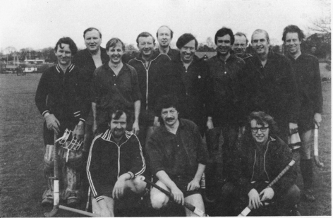
The Jack Heaton, Bob Caine, Robin Jones Jubilee Match 1979

Mike Macadam’s 1955/56 season, where he scored 50 goals in the first team, rightly concluded with a presentation to him of the ball with which he scored the fiftieth goal. The Club subsequently received an account from the Club concerned, which will be nameless, for the cost of the ball. The Tankard with which he was also presented was marked ‘To 50 Goal Macadam from the Ten Who Made Them’. His County Career was interrupted by a posting to London and was resumed on his return, since when there have been few seasons when he has not been the Club’s leading goal scorer, being mainly when Chris Matthias dared to overtake him. Mike has captained a number of teams, being Chairman also and latterly has taken one of the main organising roles in the Northwest League, as well as organising Club Umpires.

Notable goalkeepers have emerged and added great character to the Club, Gerry Vaughan, Gerry Reakes Williams, Arthur Blackhurst, Bernard James, Hibbert Binney, Bob Taylor, Rod Lyon, Steve Carr, Austin Savage (Great Britain), Geoff Graham, David Mews and most recently, Rob Evans.

Centre-forwards of the calibre of Geoff Jardine (England Trialist), Mike Egerton (Scotland) and Robbie Smith (England) have also passed through the Club.

Without umpires the game has never been satisfactory and over the years the Club has produced its fair share of umpires for the Northwest Hockey Umpires Association appointments in the League fixtures and in many lower team Club fixtures every weekend. In particular, Roger Ball, Hesketh Hughes, Peter Cross, Peter Jones, Tom Wilson, Tony Powley, Mike Macadam, Steve Fletcher and Joe Fenlon should be mentioned. Perhaps it is true to say that Goalkeepers, as a close second to Umpires, have contributed more to most clubs, both on and off the pitch, than any other category of member.

The achievement of 99 Cheshire Caps by Donald Hughes in the 1960’s added to his Oxford Blue and Welsh International appearances has not been equalled by any other Oxton Player, although Austin Savage has had a much longer International playing career in goal for Great Britain and Wales. Stuart Edwards captained Cheshire for some years and would surely have played for England had his medical training not been given priority.

John Forster came to the Club in the early 1960’s having already represented Great Britain and played in the County Championship winning side in 1963/64 before giving up County hockey to give proper time to captaining the Oxton side in 1970/72.

Brian Owen and Nick (K.G.) Parry both played for Wales during the 1960’s in addition to their many Cheshire appearances.

Oxton Hockey Club
1965/66
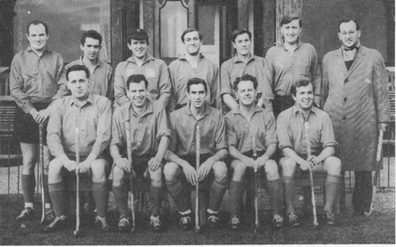
1st XI 1965: Five Internationals and only one who did not play for the County

That many of these players from the 1960’s (which included Mike Egerton, Robbie Smith, Julian Manchett and Peter Renshaw) continued their hockey playing careers with other clubs for differing reasons, was Oxton’s loss. Only David Renison, the present Chairman and John McNamee, the present Veterans Captain remain as players from that most successful era. That they have until the Centenary Year continued to play First Team hockey is a painful reminder of the drop in playing strength recently.

At County level and sometimes above, Oxton have provided County Presidents in C. W. Marshall (1922-24), P. M. Cross (1978-81) and H. R. Hughes (1985-87), County Captains in R. M. Stewart (1922-24), D. C. Hughes (1964-65), S.J. Edwards (1973-76 and 1977-78), and League Administrators more recently in M. F. Macadam and Robin Miller.

No recent history of the Club would be complete without mention of Tom Wilson, who, after a long and skillful playing career, has since devoted so much time to the social, catering and money raising sides of the Club.

Many members have used their talent and energy on the essential Administrative and Social side of the Club and names such as Peter Harris, Chris Jeans and John Allen keep appearing on the list of office holders as a tiny reminder of many years spent in keeping the Club running smoothly. If they have not been mentioned here, it is because of obvious deficiencies in the writers powers.

The Present

In 1988, Steve Lawrence is Captain for probably a record fourth season running and has the makings of a talented new team of younger players such as Rob Evans, Andrew Lett and Phil Metge. The Club hopes this will be the dawning of a new era of success.

The Future

Whatever has gone before in the hundred years to date continues to benefit those who remain as members and it appears clear that those who have put most into the Club over the years have also obtained most out of it. May that encourage those in the future to pour themselves wholeheartedly into it for the benefit of themselves and others.

Acknowledgement

The Club is extremely grateful to Leslie Bibby in particular and to Peter Cross, Clifford Cook, Hesketh Hughes, Mike Macadam and David Renison for putting together this token account of the first 100 years of Oxton Hockey.

PART 2

HISTORY
1988-2013

‘Sticking together since 1888 and still pushing forward’

Back in 1988 we moved into our second century. We could never have envisaged what changes there were ahead. There have been many changes of rules to our beloved game in the last 25 years, not to mention the changes of home venues and clubhouse, but more of that later.

The Centenary

It would be remiss of me not to remind you that our centenary year in 1988 was also the year of the ‘Seoul Olympics’. Some of you may remember that at our end of season Hot Pot, our guest speaker was Ian Taylor (the GB goalkeeper at Seoul). He entertained us by revealing just how hard they had trained as GB, and the promises they all made to each other, that even when they were away on holiday, they would go through a strict training programme each day (which they actually all stuck to). All this was to be in the best condition of their lives, in order to win the ultimate prize in amateur sport an ‘Olympic Gold Medal’.

We were also presented with a boxed set of Olympic gold medallions, a unique gift from Ken McBride (a former member). The medallions had been commissioned Phil Appleyard, then Chairman of the Hockey Association, who had spoken at our Centenary Dinner. Our President accepted the medallions on the club’s behalf, saying we were honoured to accept such a gift and would take great care of them.

The Rule Changes … Goalkeepers

Firstly we focus on the goalkeeper, who these days, resembles something out of Star Wars. With all the body protectors (chest, arms, thighs) and padded shorts for when they turn their backs. Helmets instead of wire-framed face-masks, and gigantic pads, twice as thick and wide as the originals made of lightweight polystyrene-type material. Kickers the size of British Airways hand luggage bag, and gloves (known as hand protectors) the size of dinner plates. Yet somehow clean sheets are rare....now why is that!!! Yes they are always on the floor, and with all that kit on, struggle to get up quickly. They can even use their hands to clear a ball whilst lying on the ground, which is just as well given the previous fact. Saying that, you have to be a brave person (or some say daft) to even consider going in goal, given the speed of the ball these days, but someone has to. So hats off to all goalkeepers they certainly earn any praise they receive.

Outfield Players

Players can use the edge of the stick (removing that wonderful skill of reverse stick stops and hits), no offside (great for strikers) and you can self pass at free hits and long corners. Greater protection for the player on the ball with most tackles from behind being penalised as soon as the stick is touched. But the most important introduction is that all games must now be played on an artificial surface (Astroturf). The alterations of the rules has encouraged those youngsters with skill to play at higher levels than before, with confidence and safety. Finally the latest changes… any touch in the “D” by a defender or attacker is a goal. Even own goals off defenders or goalkeepers body or feet. My, how our game has changed since our centenary, and how many more changes will be made before our next milestone ?

The League and Cup Successes (Men)

The Club went from strength to strength, and the 1990s (with the impetus of the new shared Astroturf pitch on the Birkenhead School grounds next to the Pavillion), was the most successful decade ever in Oxton’s history. Our first major success was winning the H. A. Trophy at Milton Keynes in 1993 beating Halifax, a very special moment in our Club’s history. In that same year the men’s U21’s won the Cheshire Cup with a very young side.

In 1999 the Veterans won the Cheshire Cup for the first time beating Bowdon 2-1 (not bad for a team who were mostly over 50). Moving into the Millennium, in the 1999/2000 season the 5th team won every league match scoring over 120 goals and conceding less than 20, a feat not matched in the Club’s history. The Club’s leading goal scorers, often referred to as the S.A.S (Smith and Swaine) terrorised defences and both scored over 50 goals each. In 2005 the 2nd XI won the National 2nd Team Trophy and in 2012 the 1st XI won the Cheshire Cup for the first time beating Bowdon 2-1.

2012/13 Season

The 2012/13 season has been the best ever points scoring season for our Mens’ 1st XI. They finished 2nd in the Northern Premier Division 1 league, just missing out on promotion to the National League. The Manager, Coach and players, all deserve our congratulations and we can all hope the improvement continues next season and beyond, taking the Club to new heights and securing the future of Oxton for many years to come.

The 2nd XI started the season well, but suffered a loss in form which led to 3 defeats in a row before Christmas. However they returned to form narrowly missing out on promotion. As you can see at the top end of the Club the future is bright. The 3rd team & 6th team were relegated, the 4’s finished mid table and the 5’s had an inspired end to the season to stave off what was certain relegation. All in all, a mixed season, caused in no small part by lack of availability of players and injuries, something we need to address if we are to be more successful in the future.

The three Ladies teams have all had a tough time this season, lots of injuries to key players and a number of absentees due to maternity. This has meant teams have fielded a lot of younger players who quite often have been somewhat overpowered by the strength of older, more experienced players. To their credit they stuck at it and will be better for the experience next season. All of the Ladies teams finished in the bottom half of the table and remain in the same leagues next season.

Finally the Mixed team had an excellent season winning their league, in no small way thanks to their teamwork. Each player was treated equally and all played their part in the teams success, only losing once all season, and that was in the 3rd round of the National Cup. Take a bow!

The Veterans

The Veterans continued to take part in the Aylesbury tournament for many years often falling at the final hurdle to Eastcote, (or as we called them Eastcote & Sons). We all remember very youthful Eastcote sides winning year after year (bringing in fresh players for the final stages). Finally after many years of endeavour we overcame the youth of Eastcote to win for the first time in 1994, and followed up with further wins in 1995, 1997 and runners up in 1998.

The 90’s was also the decade that our Veterans entered into the National Veterans Cup competitions, and had the luck of being drawn away in every round for nearly 3 years. Some of the away matches included Lincoln, Adel (York), St Albans, Keswick, Ashby de la Zouch, Whitley Bay, and Plymouth (in the Quarter final). Much fun was had by all, whatever distances we travelled or the quality of the opposition.

Might be time to enter the Vintage cup … legs willing!

Ladies Section

1997 was a major landmark in Oxton’s history, the first ever Ladies’ section was officially formed and entered into the Cheshire League. The very young side guided by a couple of seasoned campaigners topped the league in their first season, and then went on to gain promotion for the next 5 (yes five) seasons finally getting into the Northwest Feeder league, an amazing feat and congratulations to all who played. Since then with increased ladies membership we now have 3 ladies teams playing mostly more experienced sides, but gaining in confidence week by week. We have ‘back to hockey’, a great idea to boost playing membership, and adding that strength and experience to those sides full of youngsters. This idea will remind those current 1st/2nd team players that they are likely to be playing for a long time, retirement - forget it!

In 2005 Melinda James became the first female Chairperson of the Whole Club and served 2 years, this was a big step towards ensuring our future, as the ladies play a key role within the club both on and off the pitch.

The Junior Section

This is the future of our Club, and a number of senior players turn out every Sunday morning to pass on their skills and knowledge to children ranging in age from 6 to 14, who, over a few hours seem to enjoy the hockey whatever the weather. Approximately 100 youngsters are registered for this session of which 65+ turn up each week, hoping to be a star of the future, and who knows, they may just be that. But to the Club they are all stars, our future is in their hands for years to come. This section is probably the most important section in the Club, and we owe so much to those who have given up (and still do) their Sunday mornings to help with the coaching over many years.

Competitively, the youngest members play in occasional tournaments and festivals, and are slowly introduced to represent the Club in the Beavers U13 mixed team who play against other clubs every week. The boys then graduate to the Badgers U15 team and train one evening a week and play every Saturday, in preparation for senior hockey, whilst the girls move directly into the ladies’ training and teams.

The U16 boys’ team come together to play in various National and North cup competitions whilst the players take the field regularly on Saturdays for the men’s teams. Similarly the U14 girls come together for occasional matches.

Due to demand the 2013-14 season will see the U10 and U12 teams competing in the newly re-formed Merseyside ‘leagues’ and the U14 girls and boys will enter the EH Development leagues.

Umpires

We now have an expanding number of umpires, both male and female, who give up their time freely every Saturday (and sometimes Sundays) to allow us to play and hopefully enjoy ourselves.
We have some newly qualified level 1 umpires, all of whom can be proud of their achievements and their consistency for the club. The Club has been very active in coaching and mentoring umpires recently. With the Club running so many teams, it has been very important to keep producing competent umpires, to enable so many teams to play every Saturday.
In the 1992/93 season Oxton Hockey Club were winners of the “Wilkinson Sword” annual award presented by the North West Hockey Umpires Association. This award was for the friendliness and hospitality shown to visiting umpires over the course of the season

The League

The restructuring of the men’s leagues on a number of occasions has made life difficult for the fixture secretaries and the various captains
( even with the advent of email and face book) trying to muster 120 players on the pitch every week, and that doesn’t include the Badgers and Beavers. We have enjoyed mixed fortunes in the various leagues with both promotions and relegations since the Millennium.

The Finances

Probably the most important change in Hockey is, that there are no more grass hockey pitches used. The game is now played on Astroturf in one form or another (water based / sand based or hybrid) all of which has to be financed, and often stretched the clubs financial resources, Oxton are fortunate to have some very generous former and current members. The Club owes a great deal of thanks to those who have made contributions to our fund raising projects, many of whom have remained anonymous. Clubs often rely on generous members in one way or another and without their donations, training facilities and coaches would be beyond our means. Our thanks are due to each and every one of them for their contributions. It is surprising just how much goes on behind the scenes to enable the Club to reach any land-mark, let alone 125 years.
Every senior Club now employs at least one qualified coach to support First and Second Teams in particular, and all of this has to be provided for in the budget. The value of coaching qualifications has been recognized in recent years, with many members gaining formal EH coaching badges, and helping with player development and Club training on a voluntary basis. This has led to the all round improvement of skill levels across the whole Club.
There are of course a number of players and members who also give their time freely on Committees, Captaining, Presidents, Chairpersons, Treasurers, Secretarial duties and Catering not forgetting the Umpires. It is like a big jigsaw and so many people have played an important part in the Clubs History. It would take far too long to name them and without wanting to embarrass a single person by either mentioning them or even worse forgetting to name them, it was decided it would be prudent only to name those who have created milestones thus avoiding offending anyone. You all know who you are, you have helped to make our History and as a Club, we thank you from the bottom of our hearts.

Split with the Cricket Club

Following the arrangements made in 1967, the Hockey Club had ceased renting the facilities at Townfield Lane, and had integrated fully as a part of Oxton Cricket Club. This meant that the Club became one of the sections of the Cricket Club, together with Tennis and Bowls (and subsequently Lacrosse). The relationship with Cricket in particular in the succeeding years was often uneasy. Although benefiting from the major Pavilion improvements completed in 1997, to which hockey made a significant financial contribution, by this stage hockey at all levels had to be played on Astroturf pitches. This meant that the grass hockey pitches on the cricket ground became redundant and as a result much playing activity took place remotely from Townfield Lane. Fortunately the section (as opposed to the Cricket Club) had independently raised a major sum of money to enable the joint venture with Birkenhead School for the building of an all weather pitch on the School’s land opposite the Oxton Pavilion at McAllester Field, which served the Hockey Club well from 1993 onwards.
As a sports section of the Cricket Club, hockey had lost a degree of independence, with a resultant inability to fully control hockey matters. The section was in a minority on the Club’s General Committee, which led to occasional tensions. The situation came to a head in 2009, when following the Cricket Club’s attempts to impose excessive disciplinary sanctions on the hockey section. Hockey members voted to terminate the relationship with the Cricket Club, and to re-establish Oxton Hockey as a separate Club operating on a truly independent basis.

It was therefore necessary to find a new home base for social purposes, and an agreement was quickly established with Irby Cricket Club,
which is now the Hockey Club’s venue for post match entertainment and other social activities. All of this takes a great deal of co-ordination, as the fact that the games are now played at staggered start times throughout Saturdays in particular, has had a significant impact on the post match hospitality arrangements
At broadly the same time in 2008/9, it had proved impossible to agree acceptable terms with Birkenhead School for the resurfacing and future use of the McAllester Field pitch. Accordingly, the joint venture came to an end and new arrangements were made with Calday Grange School for the use of their pitch at Paton Fields, adjacent to the A540 at Caldy. This became the Club’s main match venue, with the continued use of other pitches at West Kirby Grammar School and Birkenhead Girls School.

Conclusion

These major changes have clearly heralded a new era for Oxton Hockey in the lead up to the Club’s 125th Anniversary. The arrangements at Irby continue to develop and the Hockey Club is exploring options for the construction of an artificial pitch at this site, as well as other possibilities for new playing facilities locally.
Since 2009 the Hockey Club has had a couple of challenging playing seasons, with the restructuring of the leagues and unavailability of players, culminating in the loss of the men’s 7th team last season. We all have an important part to play in Oxton Hockey Club, whether it is playing, being a captain or club official, or just being a parent :- our future is in your hands. By working together we can ensure that our club will still be around to celebrate 150 years and beyond.

Acknowledgement

The Club is extremely grateful to David Renison, Alison Foster, Mike Flynn, Melinda James, Richard James and Brian Swaine for putting together some of the last 25 years history of Oxton Hockey.

A collection of club photographs and trophies etc from 1897 to 2013 (which have all been digitised), are now available on C.D. and can also be seen on the Club’s website.

ONE HUNDRED AND TWENTY FIVE UP

Eighteen eighty eight in Birkenhead Park,
Oxton Hockey Club made it’s very first start.
In rather long shorts and leather studded boots,
The future decided they put down their roots.

long curved sticks on pitches made of grass,
They developed their skills to shoot and pass.
A leather ball with a heavily stitched in seam,
A game played by gentlemen on the green.

The game has evolved so to the equipment,
Fitness levels and the individual’s commitment.
Past members would be proud of our Club today,
In Men’s and Ladies leagues, we turn out to play.

To all of you, who have played your small part,
We have come a long way from a humble start.
The personnel may have changed, the colours too,
But our Club is still going, and that’s down to you.

One hundred and twenty five years we celebrate,
We hope future hockey generations can emulate.
Hoping to build on the successes of the past,
You can be sure Oxton Hockey is here to last.

Brian Swaine
2013

